Spencer Swartz

* 1. 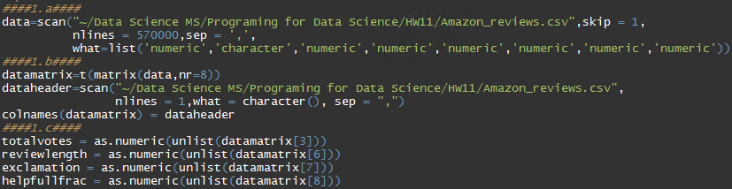
  2. “”
  3. “”
  4. Based on the bellow outputs there will be no rows that are excluded
     1. 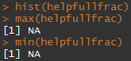
     2. 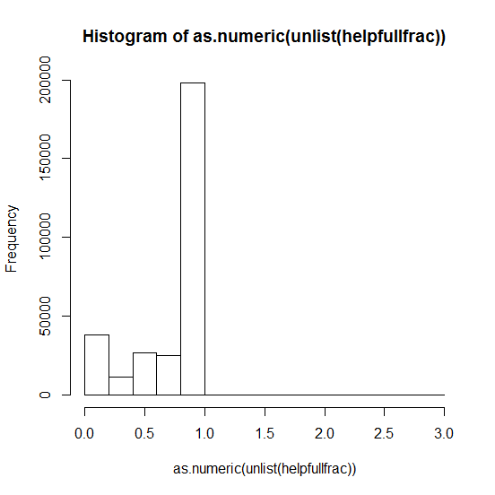
  5. There were no rows with unrealistic values this may be because some rows were excluded within the Python homework as they were causing trouble when creating the pandas data frame. The only rows that were excluded were those without a value.
  6. 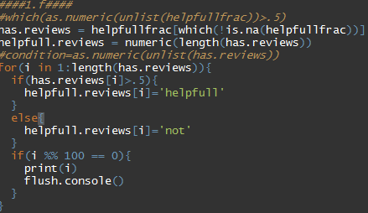
     1. 
     2. It may be beneficial to take the log of the length to be able to read the box plot better.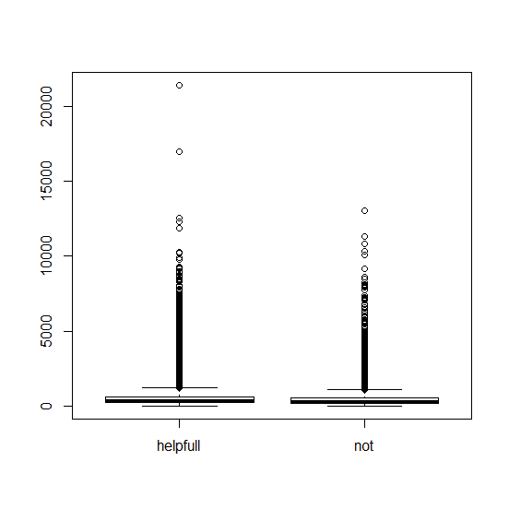
     3. After taking the log we can see that there seems to be a slight increase in length of the helpful comments.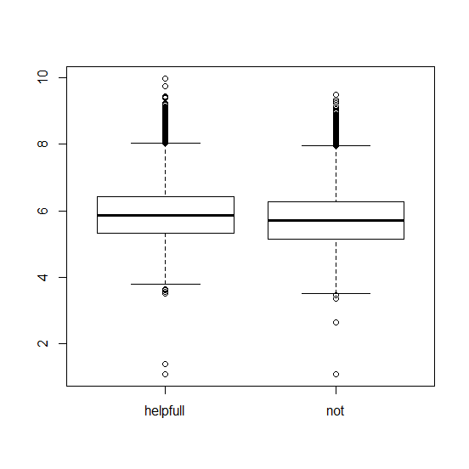
     4. 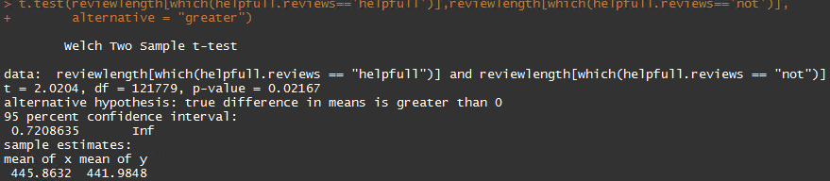
     5. The T test returns a p-value less than .05 showing us that there is significants that the reviews that are helpful are longer.
     6. The max of all the reviews is 923
     7. 
  7. 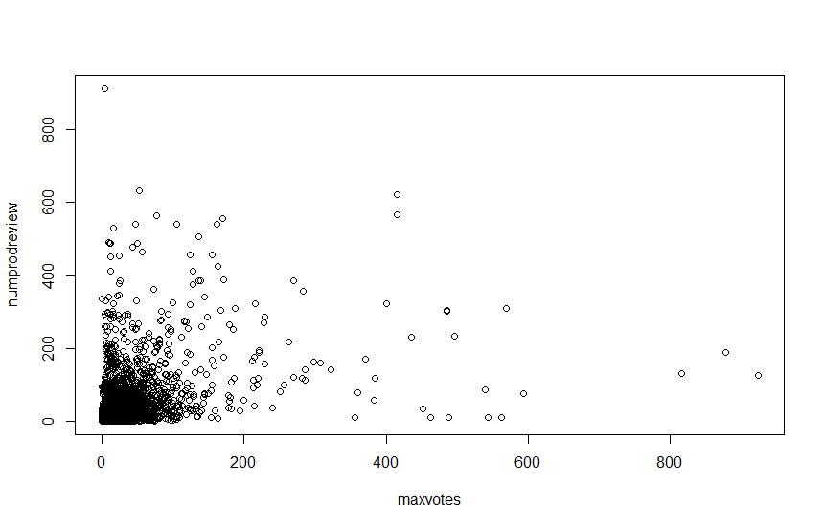
     1. There is not a strong visible trend.
  8. 
  9. 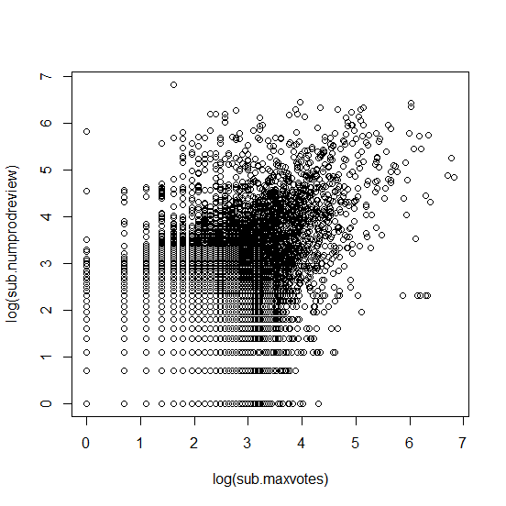
     1. Once the log function was applied it is more apparent that there is a linear trend to the data. As the log of number of reviews increases so does the number of votes.